VETERANS DAY BIG MONEY BINGO

14 Games pay up to $700
Specials\ Jackpot pay $600, $1100 & 1275 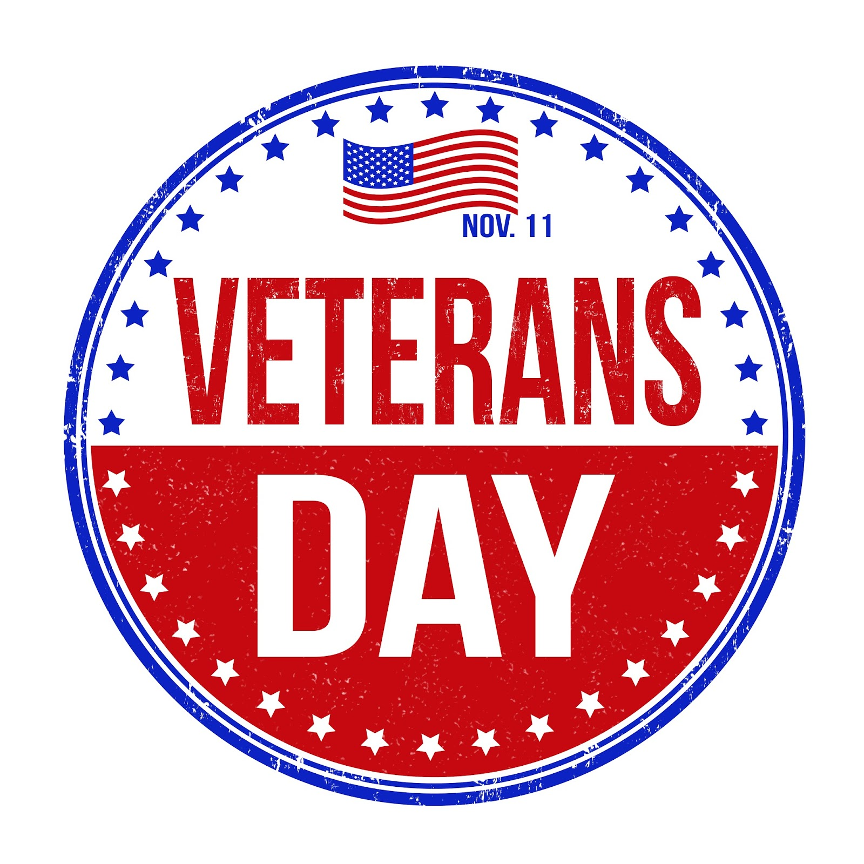
$60 person-Includes Dinner, Block of 9 game packet, and 1 game strip for Jackpot & 2 Specials
Doors Open 4 pm Dinner 4:30pm to 6:00pm Bingo 6:30pm
ADDITIONAL Game papers for sale @ 4:30pm *
*
9 pack $15
6 pack $10
3 pack $5
Specials/ Jackpot $1

Free Coffee & Iced Tea available until last break.
Soda & Snacks sold during each of two 15 minute breaks

To Reserve Tickets call LaRue Stevens @ 301-829-2510, then mail
a check within 7 days in the pre-addressed envelope enclosed.
You need to include the FIRST & LAST Names of all ticket holders. We will
mail your tickets to you. AFTER NOV 4th NO TICKETS CAN BE
MAILED, BUT YOU CAN STILL CALL TO RESERVE THRU WED. 11/8
(as available). The 8th will allow LVFD time to place the food order based
on the tickets sold for event.

TICKETS RESERVED NOV.4th thru NOV. 8th MUST BE PAID FOR IN CASH &.
PICKED UP ON THURSDAY 11/9 OR FRIDAY 11/10, at the Libertytown
Fire Hall. Early Reservations strongly suggested for assigned seat.
All checks will be deposited prior to event 11/11.

CHECKS PAYABLE TO & ALL PROCEEDS BENEFIT THE LIBERTYTOWN FIRE DEPT.
LVFD RESERVES THE RIGHT TO REDUCE PAYOUTS IF LESS THAN 160 PLAYERS. NO REFUNDS.
